# CS430

# HW4

# Team “Yamaha Piano”

Malcolm Machesky and Adrian Kirchner

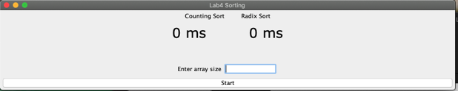

# Project Management

Table presented by name of participant and by day

|  |  |
| --- | --- |
|  | Wednesday |
| Malcolm Machesky | * Modified (Gui.java) (5 min) * Worked on instruction ppt and Project management (10 min) * Helped combine GUI and sorting algorithms (20 min) * Worked on (RadixSort.java) (2hr) * Worked on analysis (1hr, 50 min) * Total Hours: 4 25 min |
| Adrian Kirchner | * Worked on sorting algorithms in (CountingSort.java) (2 hr) * Helped combine GUI and sorting algorithms (20 min) * Modified (Gui.java) (5 min) * Worked on analysis (2 hr) * Total Hours: 4 25 min |

## Algorithm comparison and analysis

Below is a table of results from running our program on various sizes of arrays. We used a maximum value of 10000000 so that the differences in performance for counting sort would be apparent. We also ran the same dataset through the previous assignments and included the results.

|  |  |  |  |  |  |  |
| --- | --- | --- | --- | --- | --- | --- |
| n | Counting(ms) | Radix(ms) | Quick(ms) | Heap(ms) | Insertion(ms) | Merge(ms) |
| 1000 | 13 | 1 | 1 | 1 | 4 | 1 |
| 10000 | 13 | 2 | 1 | 1 | 55 | 1 |
| 100000 | 20 | 11 | 8 | 11 | 1574 | 10 |
| 1000000 | 152 | 103 | 100 | 133 | 162575 | 107 |
| 10000000 | 1279 | 988 | 1088 | 2420 | N/A* | N/A* |
| 100000000 | 13947 | 8498 | 11969 | 37957 | N/A* | N/A* |

*Homework 1 took too long to run with the larger values of n, and so these have been excluded.

Radix sort is the fastest sort so far, and counting seems to be somewhere in between heap and quick sort with this range of values.

# Sorting Algorithms Analysis

## CountingSort Analysis:

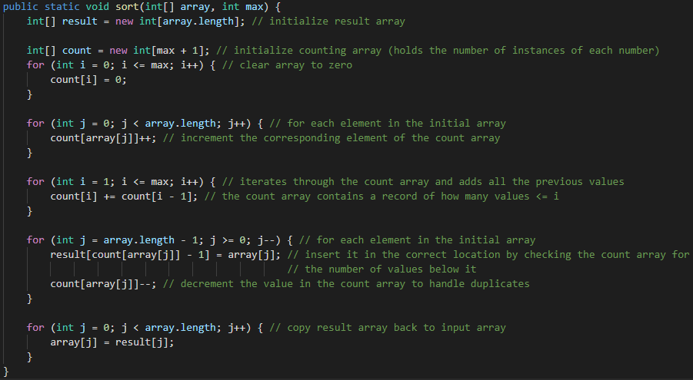

Counting sort consists of several loops that iterate through arrays of size n or size max. Combining these gives O(n + m) where n is the number of elements in the array and m is the maximum value of the array.

Line by line breakdown below:

public static void sort(int[] array, int max) { //O(m + n)

    int[] result = new int[array.length]; //O(1)

    int[] count = new int[max + 1]; //O(1)

    for (int i = 0; i <= max; i++) { //O(m)

        count[i] = 0; //O(1)

    }

    for (int j = 0; j < array.length; j++) { //O(n)

        count[array[j]]++; //O(1)

    }

    for (int i = 1; i <= max; i++) { //O(m)

        count[i] += count[i - 1]; //O(1)

    }

    for (int j = array.length - 1; j >= 0; j--) { //O(m)

        result[count[array[j]] - 1] = array[j]; //O(1)

        count[array[j]]--; //O(1)

    }

    for (int j = 0; j < array.length; j++) { //O(n)

        array[j] = result[j]; //O(1)

    }

}

## RadixSort Analysis:

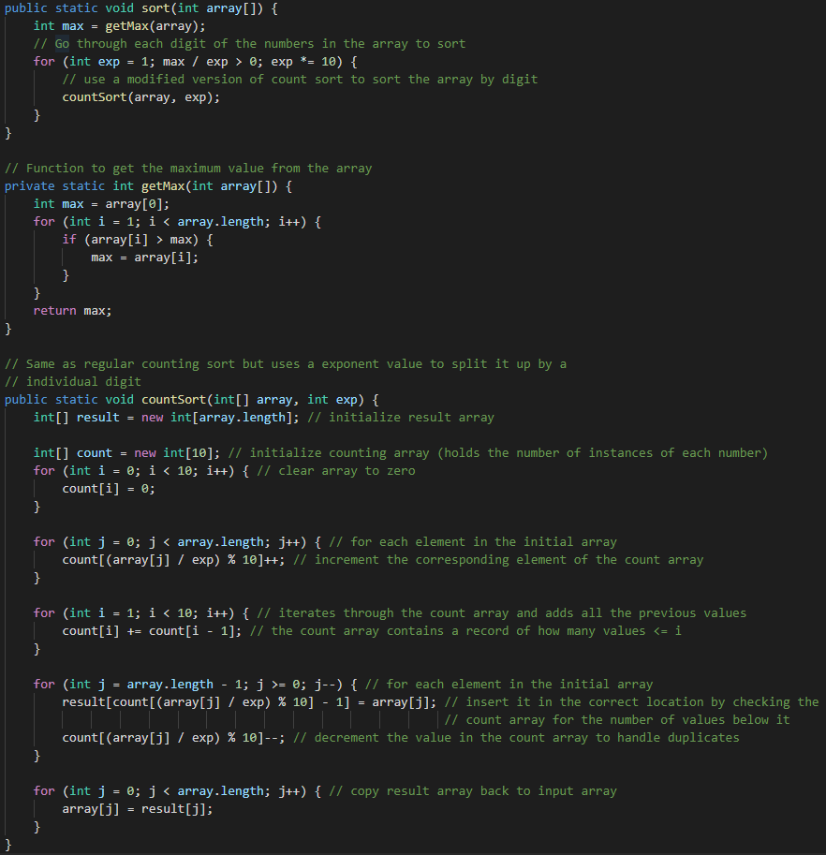

The counting sort used here consists of several loops that iterate through arrays of size n or size max. Combining these gives O(n + 10) which simplifies to O(n) where n is the number of elements in the array and 10 is the maximum size of the array as there are only 9 digits.

The counting sort is run once for each digit of the max value in the array, so log(max) times. This gives an overall time complexity of O(n log(m)) where n is the number of elements in the array and m is the maximum value.

Line by line breakdown below:

public static void sort(int array[]) { //O(n log(m))

    int max = getMax(array); //O(n)

    for (int exp = 1; max / exp > 0; exp *= 10) { //O(n log(m))

         countSort(array, exp); //O(n)

    }

}

    // Function to get the maximum value from the array

private static int getMax(int array[]) { //O(n)

    int max = array[0]; //O(1)

    for (int i = 1; i < array.length; i++) { //O(n)

        if (array[i] > max) { //O(1)

            max = array[i]; //O(1)

        }

    }

    return max; //O(1)

}

public static void countSort(int[] array, int exp) { //O(n)

    int[] result = new int[array.length]; //O(1)

    int[] count = new int[10];  //O(1)

for (int i = 0; i < 10; i++) { //O(1)

        count[i] = 0; //O(1)

    }

    for (int j = 0; j < array.length; j++) {  //O(n)

count[(array[j] / exp) % 10]++; //O(1)

    }

    for (int i = 1; i < 10; i++) { //O(1)

        count[i] += count[i - 1]; //O(1)

}

    for (int j = array.length - 1; j >= 0; j--) { //O(1)

        result[count[(array[j] / exp) % 10] - 1] = array[j]; //O(1)

        count[(array[j] / exp) % 10]--;  //O(1)

}

    for (int j = 0; j < array.length; j++) { //O(n)

        array[j] = result[j]; //O(1)

    }

}